Sam notes
Purpose of project:
- Deploy a new more flexible content management system
- Improve user discovery of site (SEO) and conversion by reshaping content hierarchies (how do users find the website? What is the breakout of users in terms of existing customers and browsing / potential customers?)
- Apply updated visual branding to site (what are the key attributes / elements of the new brand style – what is the brand trying to convey, that the new website must also convey / achieve)
  - Have this (created by Karen – more green color – why? Lines used, percentages, shapes, etc have a tie into the name Numerator + Retail analytics
  - Have personas created a while ago

Desirable elements of the website
- Cohesive site (organized content – organic and intuitive)
- Appealing to multi-faceted audiences (able to achieve goals of key users – personas will play a key role here – get an archetype of the key users)
- Able to direct prospect towards conversion (what does a conversion look like – e.g., provides info for / schedules a demo – internal stakeholders point of view / targets – ask in questions)
- Highly navigable to skim and deep dive (What are the new emerging navigation approaches that are adapting to the more visual and shorter attention span of users online?) Drop downs are still in vogue – have a sentence after the title/drop down

Discovery audience
- Organization (primary)
- Customers (end-users - included)
- Competitors / Industry (in-direct via org and customers as well as websites?)

Discovery format
- Internal document review (customer survey results, existing user personas, etc.)
- Kick-off session
- User interviews
  - Current draft
    - What is most important to you when using the Numerator website?
      - (Tell me which features you use and would be most helpful to you in your role) (Maybe go even higher upstream with starting questions – how often do you use the website, by account login versus general site? When/why do you come to the Numerator website? What content, what tools, etc. do you like the most…? How easy is it to find what you are looking for?)
      - (What's missing in your opinion)
    - When was the last time you worked with Numerator?
      - (Tell me about your experience)
      - (How did you first hear about them?)
      - (What was the last thing you saw / read from them?)
    - What other products or services or providers have you used similar to Numerator?
      - (Tell me who they are and what your experience was like with them)
      - (Was there a one-of neutral that colored your decision)
    - What you want to see from the Numerator website to make your job easier?
      - (Tell me possible features that we can provide that will drive you to do more business with Numerator)

  - Draft considerations
    - Questions should be structured by Internal and External stakeholders. Current draft questions are good for external stakeholders
    - Schedule time with Jessica to talk through some of these things: Who are the internal stakeholders that will be interviewed? What function / involvement in the project? What can they help us better understand for the project to be successful in meeting its goals?
    - Need to capture from Internal Stakeholders their view of
      - Who comes to the website, why they come (what they are looking for)
      - What type of user accounts are there?
      - How does Numerator make money?
      - What types of user accounts / account mix is being targeted and how can the website help capture and serve them?
      - What is the current website doing really well?
      - What is the current website failing to achieve? POV on why this is the case and what needs to be done to solve this

    - Who will be the external stakeholders? Which segments/industries should be targeted? Manufacturers, Retailers and Agencies….? What level of user engagement?

- Website content audit (existing and proposed/envisioned currently by client)
- Site map

Discovery outputs
- Key user personas
- Pains and Gains (customer unmet needs and desired outcomes)
- Inventory of content to exist on the new website
- Synthesis of content into new website structure

Definition
- Visualized site map and wireframes of new website

Design and definition

Executive Summary

Dear Jessica,

We are excited to partner with the Numerator team on your website redesign project. We understand the purpose for this project is to re-platform to a more flexible content management system, reshape global content hierarchies in order to improve SEO and conversion efforts, and apply Numerator’s updated visual branding elements sitewide.

We also understand Numerator is seeking an objective and experienced digital design firm to create and maintain cohesion across the site while appealing to a multi-faceted audience. Moreover, the site needs an intuitive and scalable content hierarchy, where we lead prospective buyers down a path to increase our chances for higher conversion actions. Lastly, the use of design should be simple and sparse in copy, as to entice users to easily skim, then dive deeper. Think more magazines and less newspapers.

Usman Group is confident that our team will serve as an invaluable thought partner, working closely and collaboratively with your Head of Brand Management, Karen Vu, to create an intuitive and professional B2B website that is on-point with the Numerator brand. Our previous work with ShopperTrak, who happened to face similar challenges, has given us a deeper understanding of your industry, targeted keyword phrases, and ideal buyer types. This will serve as an invaluable asset (and time saver) as we hit the ground running.

When going through your evaluation criteria, I hope that Numerator will not only consider our expertise in planning, designing, and building top-notch online experiences for B2B software companies, but also our ability to serve as an objective thought partner that will be there for the Numerator team for many years to come.

If you have any questions, or need further clarification on items covered in this proposal, please feel to contact me directly. We are excited to partner with your company on this very important project and look forward to building a trusted business relationship with the Numerator!

Sincerely,

Naveed Usman
Principal + CEO
847-325-5466
naveed@usmangroup.com

Our Approach

Discovery
Through in-depth analysis of your organization, industry and end-user needs – we will begin by examining key user needs, motivations, frustrations and expectations. Prior to the “kick off” session, we will distribute a series of custom-tailored survey questions to internal stakeholders to share responses during the session. These collections will then serve as the catalyst for lively conversations (and decision-making) during the kick off meeting.
We will use this information to identify the opportunities and challenges to inform the new website structure and functional requirements. We will also reference your previous findings to best address the needs for each audience type.
By better understanding each audience’s pain points and needs, we are far more likely to craft a website experience that is useful, engaging and highly intuitive. As part of our discovery process, we will conduct:
- Key Website User Personas - This exercise involves creating various archetypes in order to ground ourselves in the type of people who will be interacting with your content. Defining each persona’s motivations, frustrations and how it can help are essential components to building out an insightful persona.
- Prospective clients: researching our services, reviewing our content to see what Numerator’s capabilities are
  - SMB / Midmarket companies
  - Enterprise companies
  - CPG, Gen Merch, Restaurant companies
  - Retailers
- Current clients: reviewing our latest content, getting ideas for custom projects / new initiatives (possible upsell/cross-sell opportunities)
  - SMB / Midmarket companies
  - Enterprise companies
  - CPG, Gen Merch, Restaurant companies
  - Retailers
- Press (Journalists)
- Procurement
- Job Seekers
- Pains and Gains - Pains and Gains is an exercise in grounding us in the pains that your user’s experiences and what gains they are looking to accomplish or solve. We then use these findings to prioritize proposed features that will articulate how we can best help them.
The benefits of this kind of planning are two fold. First, it grounds us in the multi-dimensional reality of your audiences, allowing us to be more thoughtful and intentional in the work that we do. Second, it serves as a compact deliverable, so that other internal stakeholders at Numerator are more informed and fully aligned with our go-forward plans.
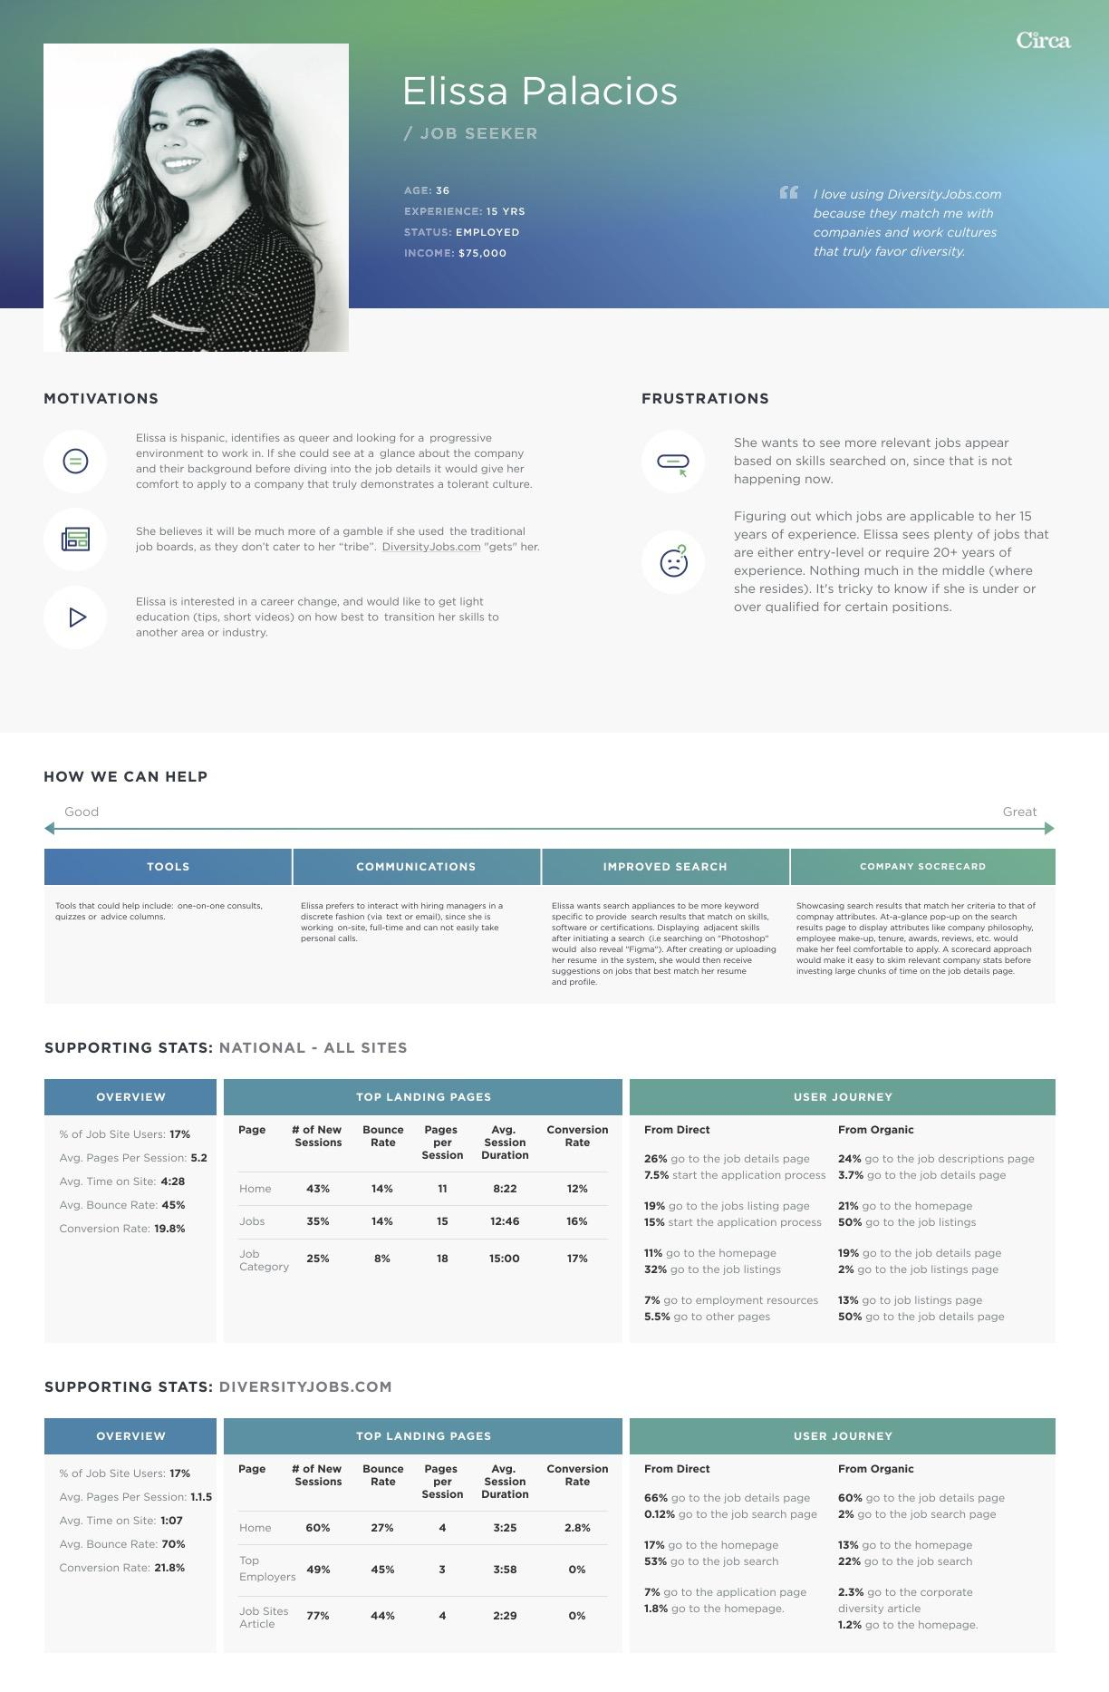
Sample of Our User Persona Deliverable
As we continue to validate key assumptions, we will inventory the many forms of content that will ultimately exist on the new website via a content audit exercise. I’ve created a short video to explain how we approach the content auditing process here: https://www.loom.com/share/35ef818f5db84d749e5751bf5fb88beb

Page headings, copy, meta-data, images, videos, links, articles, external downloadable files (PDF’s, word documents, excel spreadsheets) and other non-structured content elements will all be collected using our online tool, GatherContent.
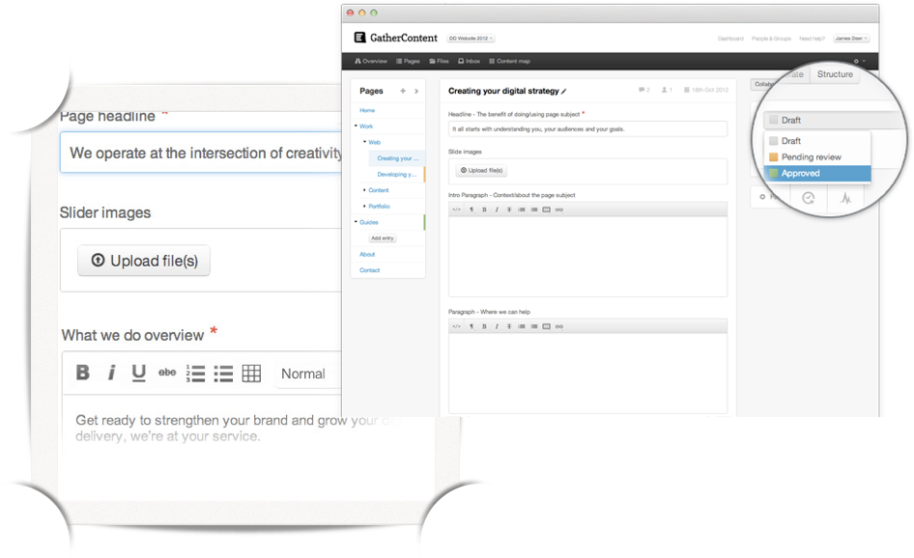
Screenshot of the GatherContent tool
Once collected, we will reorganize and synthesize all of your content assets into the new site structure and assign them as either in draft, in review or approved for publishing for each page. This is essential if we are to produce a thoughtful and scalable information architecture. More importantly, this deliverable will be extremely helpful for your organization in the creation and management of future forms of content - once the website has been built.
Search engine optimization (SEO) will also be an important factor as we shape our plans for content. Our approach to address SEO at this stage will include keyword research, Google Search Console auditing, page indexation, page redirects, and on-page SEO instructions (including short, descriptive and keyword-rich URL’s).
We will also integrate an accessibility overlay tool, powered by accessiBe. They offer an easy to use plugin for $650 per year, which will ensure the website is WCAG & ADA Compliant.

Definition
Once we have gained a deeper understanding of your key audience’s needs, and have determined how the website can best meet those objectives, we will visualize page structure in the form of a detailed sitemap and a series of low fidelity wireframes. This will allow us to clearly articulate the look and feel of core page templates, and better collaborate on overall page functionality, hierarchy, flow and interactions.
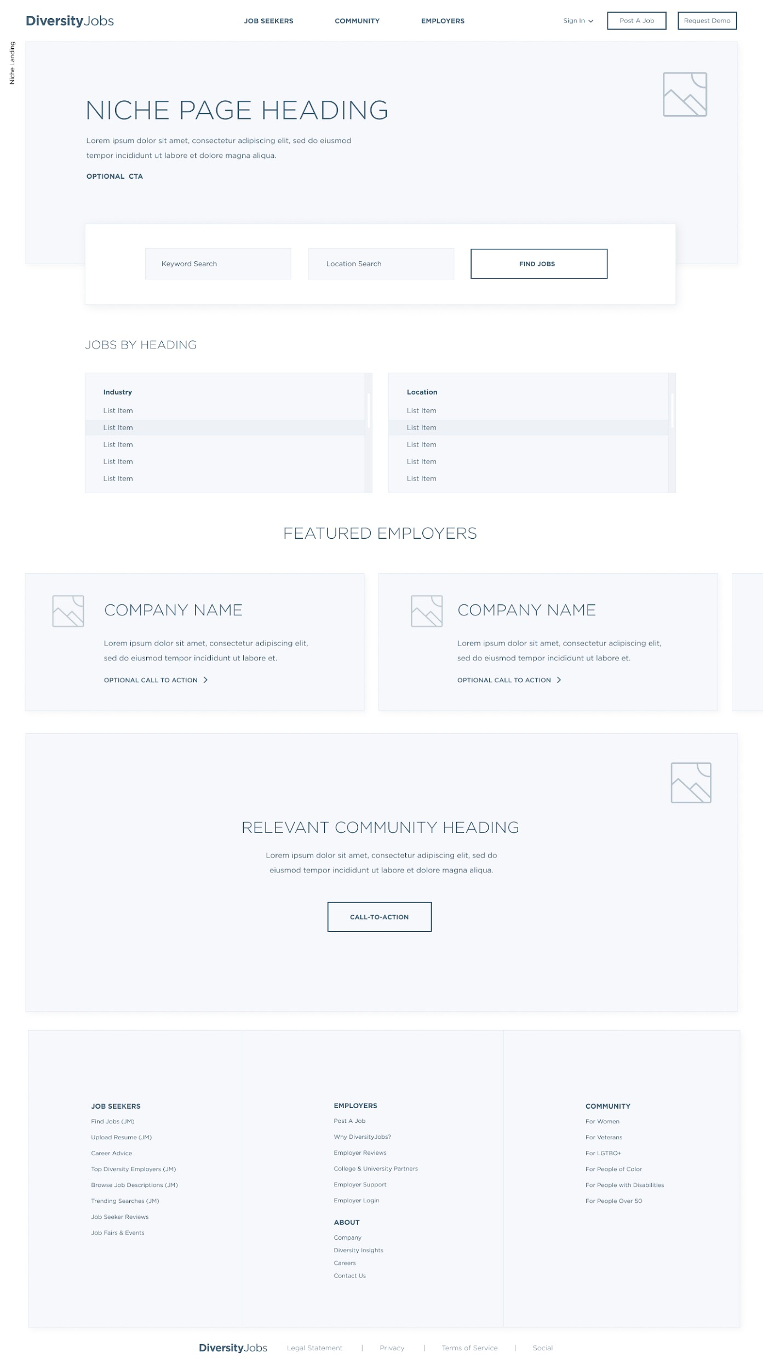
Sample Desktop Wireframe Deliverable

Design and Development
During the design phase, we will begin to apply structure (in the form of wireframes) and polish (in the form of graphic design) to communicate our ideas to you visually. With finished content in hand, we combine your working assets (copy, images, documents and data ) into our custom designs. This approach avoids any surprises and treats your content as intentional elements of the user interface.
Development is where we begin to “take apart” the approved custom design layouts and reassemble the pieces into useful bits of semantically written HTML/CSS code. It is during the development process that you will begin to experience true interactions, while we apply the functional requirements applicable to each page.
Once we have completed code production of all page templates, we will test our code against a variety of modern-day web browsers and mobile devices to ensure design integrity, quality assurance, and optimal load times. After thorough quality assurance testing has been completed, our team will implement these custom HTML templates into a new Wordpress instance, so that your organization may securely administer page content (both structured and unstructured) quickly and easily.

Project Scope
Deliverable | Detail
Discovery | Expert Review  - Expert review of prior customer surveys, persona profiles or any other internal documents or materials to allow us to better understand your organization.  Stakeholder Interviews  - We will develop interview questions as well as facilitate, transcribe and summarize interviews for up to 6 internal and external key stakeholders.  - We assume that your organization will help to schedule interview participants for us to conduct and record transcripts via Zoom.  User Personas  - User stories are composite profiles of your typical customer base. We will create up to 6 key user personas. This will provide guidance on which types of content (videos, case studies, blog posts, news articles, etc.) to create, alter or remove.  Content Audit  - To ensure the success of the website redesign project, we will conduct a thorough audit of all pages based on several key dimensions, including Usability, Knowledge Level, Findability, Actionability, Audience, and Accuracy. This comprehensive audit will reveal which pages are performing well, which ones require editing, which new pages should be created, and which pages need to be removed altogether.  Sitemap  - Developing a scalable sitemap is an essential deliverable to book-end the discovery process. Based on our content audit, we will have a more accurate count of the pages and can develop a plan for organizing them in a way that maximizes future scalability and user engagement.  Documentation  - We will synthesize our key findings into a portable document in order to articulate our findings, recommendations and key insights to inform the new website.
Wireframes | - Wireframes are simple black and white layouts that outline the specific size and placement of page elements, site features, conversion areas and navigation for your website. They are devoid of color, font choices, logos or any real design elements that take away from purely focusing on a site’s structure. They save time by allowing all teams to be on the same page about what the website is supposed to do and how it is supposed to function prior to moving into the design stage.  - We will create wireframes for the below (13) page templates; both mobile and desktop views.  - 1. Company  - 2. Bio  - 3. Blog Post  - 4. Download Resource  - 5. Homepage  - 6. Data Solution  - 7. Form  - 8. Industry  - 9. Snapshot Landing Page  - 10. Persona Pages  - 11. Interactive Insights  - 12. Press Release  - 13. Resource Landing Page  - Wireframes will be delivered in a single batch in the form of a screen share walkthrough explaining rationale and decision making.  - Initial thoughts and feedback will be gathered after this presentation and a review link (or email with static jpgs) will be disseminated for a full review.  - Numerator will provide consolidated feedback from all stakeholders. This will be implemented and reviewed once more for any final edits before moving into the design stage of the project.
Website Design | - We will create designs of (2) homepage concepts that will be high-fidelity and use real elements such as colors, fonts, photography and some of the content to showcase different aesthetics (or visual directions) the website can take. The concepts may not have all the elements that will be present in the final designs but rather some of them in order to demonstrate a particular look and feel.  - A winning design will be selected and will inform the design direction of the remaining pages and layouts.  - We will create high-fidelity designs for (13) page templates; both mobile and desktop views.  - All subpage designs will be delivered in a single batch in the form of a screen share walkthrough explaining rationale and decision making.  - Initial thoughts and feedback will be gathered after this presentation and a review link (or email with jpgs) will be disseminated for a full review.  - We have allotted 2 major rounds of revisions.  - Please note that design does NOT include content creation such as copy writing, illustration, graphics, photography etc. We will create icons that are pertinent to the overall functional elements of the pages we’re designing as well as icons that might represent a section on the website such as services. We will also include stock photography for all areas of the website in our designs, but due to the subjective nature of photography we would defer selection to the client.
Website Development | We propose using Wordpress as the CMS to power this new site.  - CMS will allow content administrators to easily upload new content (links to  reports, embedded videos, audio or data visualizations) and content summaries to  the website.  - The CMS should will enable the creation of new pages for longer-form content. These pages should allow content administrators to easily write and edit text, embed data visualizations and other media elements. Our designs will be modularized so that new pages can reference a set of predefined sections, so creation of new pages and layouts can be mixed and matched.  - The CMS should will include a media library that can be organized by Indicators as necessary and would allow the easy uploading of images and files.  - Includes the development of (13) theme page templates based on designs provided by the client. Theme will be built on the Bootstrap responsive grid framework.  - Pages to include standard CSS3 type animation, hovers, and transitions.  - Pagebuilder to be implemented will be Elementor.  - Installation of Yoast SEO free plugin to reuse title and meta description tags.  - Installation of Redirection plugin for the Numerator team to to assign 301 redirects, ensuring broken pages do not occur and inbound link values transfer from legacy pages to new pages.  Content Insertion & Styling  - We assume the total number of pages will not exceed (672) pages. Client will be responsible for manual content insertion and styling for the 672 pages.  Cross Browser Testing  - During our development, we will utilize the latest World Wide Web Consortium (W3C) HTML5 / CSS3 compliant code to ensure maximum compatibility with the latest versions of Chrome, Safari, Firefox, Edge, Samsung Internet, Android, Opera, Explorer desktop, tablet and smartphone web browsers.  Website Analytics Setup  - We will Integrate new or existing Google Analytics (GA) or Google Tag Manager (GTM) tracking sitewide, in order to track page performance and recorded sessions. We will also configure GA goals to ensure tracking codes are recording key conversion actions.  Website Training  - To best assist your content team with a clear understanding on how to use the Wordpress content management system, we will create a brief user guide which includes short video tutorials, clearly demonstrating how to perform basic website administrative functions.
Ongoing Support (Optional) | We will maintain the website’s software and technical updates for the duration of this project and be available to troubleshoot as needed. Maintenance support services include:  - WordPress Core, Theme & Plugin Updates  - Daily MySQL Database Backup  - Weekly File Backup  - Weekly MySQL Database Optimization  - 24/7 Security Monitoring  - Uptime Monitoring  - Error Log Monitoring  - 1 Monthly Troubleshooting Support Credit

Proposed Project Timeline
Task Name | Duration | Start | Finish | Responsible
Project Kickoff | 1d | 06/12/23 | 06/12/23 | ALL
Discovery | 10d | 06/13/23 | 06/26/23
Stakeholder Interviews | 5d | 06/13/23 | 06/19/23 | UG
User Personas | 3d | 06/20/23 | 06/22/23 | UG
Sitemap | 1d | 06/23/23 | 06/23/23 | ALL
Documentation | 1d | 06/26/23 | 06/26/23 | UG
Wireframes | 10d | 06/26/23 | 07/07/23
Mobile & Desktop | 4d | 06/26/23 | 06/29/23 | UG
Client Feedback | 2d | 06/30/23 | 07/03/23 | CLIENT
Implement Changes | 2d | 07/04/23 | 07/05/23 | UG
Client Approval | 2d | 07/06/23 | 07/07/23 | CLIENT
Web Design | 22d | 07/10/23 | 08/08/23
Initial Design Concepts | 5d | 07/10/23 | 07/14/23 | UG
Initial Client Feedback | 2d | 07/17/23 | 07/18/23 | CLIENT
Mobile & Desktop Designs | 7d | 07/19/23 | 07/27/23 | UG
Client Feedback (Mobile & Desktop Designs) | 4d | 07/28/23 | 08/02/23 | CLIENT
Implement Changes (Mobile & Desktop Designs) | 3d | 08/03/23 | 08/07/23 | UG
Client Approval | 1d | 08/08/23 | 08/08/23 | CLIENT
Development | 39d | 08/09/23 | 10/02/23
Responsive HTML/CSS Development | 10d | 08/09/23 | 08/22/23 | UG
Wordpress Development | 10d | 08/23/23 | 09/05/23 | UG
Quality Assurance & Testing | 5d | 09/06/23 | 09/12/23 | ALL
Wordpress Training | 1d | 09/13/23 | 09/13/23 | ALL
Content Insertion & Styling | 10d | 09/14/23 | 09/27/23 | CLIENT
On-Page SEO & 301 Redirects | 1d | 09/28/23 | 09/28/23 | CLIENT
Google Analytics Configuration | 1d | 09/29/23 | 09/29/23 | UG
Client Approval | 1d | 10/02/23 | 10/02/23 | CLIENT
Deployment | 1d | 10/03/23 | 10/03/23
Go-Live | 1d | 10/03/23 | 10/03/23 | UG

Project Investment
Deliverables | Responsible | Amount
Discovery | UG
Wireframes | R11 | $7,500
Website Design | R11 | $7,500
Website Development | Zealth | $15,000

Assumptions
- We will invoice 50% of the project total, due prior to project kickoff, 25% at project midpoint and the remaining 25% balance upon project approval.
- Website hosting is not included. We highly recommend WP Engine to host your website. They have exceptional pricing, hosting options and customer service.
- Ongoing support (noted on page 10) is available starting at $275 per month.
- Annual accessibility widget license for websites under 1,000 pages starts at $650 per year.
- If final requirements for any of the scope items described in this estimate extend beyond our original development effort estimation, we will provide amended estimates for those work items as necessary.
Next Steps
- Numerator: Approve Usman Group’s proposal
- Usman Group: Submit Professional Services agreement
- Numerator: Authorize Professional Services agreement
- Numerator: Issue initial 50% payment
- Usman Group: Finalize project schedule
- Usman Group: Setup online project management area and access
- Numerator: Provide all prior materials for expert review
- Numerator: Review / revise timeline to ensure project dates are achievable internally
- All: Commence project!

Company Overview
Usman Group is a 100% minority owned digital strategy firm that helps mid-sized B2B organizations plan and execute successful communications and technology initiatives that are elegant, cost-effective and easy to implement. The Usman Group has been recognized by Clutch, a nationally renowned and trusted third-party rating agency of professional services providers, as the top digital design firm in the US.
Since 2006, the Usman Group has executed hundreds of successful projects and programs for clients in the nonprofit, technology, and professional services industries. The output we produce is driven by our unquenchable passion to make things work. We give our very best from day one to produce thoughtful , attractive and effective solutions for our clients.
Work samples can be found on our Clutch profile, as well as on our website.

Why work with us?
We use design thinking to help organizations translate business objectives into tangible goals, validate what matters most, design a path forward and develop feedback loops for continuous improvement.
When we do business, you’ll always work directly with experienced talent, never junior staffers. Our curated group is comprised of seasoned professionals, heavily steeped in the world of digital.
Experience. We bring unparalleled experience and credibility to the planning and structural design of websites, software, and cross-channel digital marketing services.
Strategy. We can collaborate with your company to define a vision, strategy, framework, and roadmap. Our independent, user-centered, outside-in approach to planning keeps internal conflict and marketing bias to a minimum.
Design. We use maps, stories, plans, prototypes, wireframes, taxonomies, blueprints, and functional requirements to make the complex clear.
Evaluations. We can offer expert reviews with recommendations that provide a fresh perspective on existing products and allow refinement of plans and prototypes.
Network. Given our 17 years in business, we have strong relationships with outside market research, recruitment, communications, technology and design firms to access the right people that we need, as we need them.

References

Susan Yates
Executive Director, Resolution Systems Institute
yates@aboutrsi.org
312-922-6475 x 45

Abbie Gass
Development Director at CASA of Adams & Broomfield Counties
abbie@casa17th.com
720-523-2833

Alex Epstein
Former Director of Transportation Safety, National Safety Council
adepstein@msn.com
312-952-9552

Salvatore Cecala
New Business Developer at DreamExchange
tcecala@dreamex.com
773-682-6267

Andrea Webster
Resilience Policy Advisor at State of North Carolina
andrea.webster@ncdps.gov
919-576-6450

Cathy Hill
Vice President of Marketing at DiversityJobs
cathy.hill@circaworks.com
630-546-1564

